**AM1901i32 1.9meter Inkjet printer with 1 i3200 Printhead (the economic version)**

**$2800 -$3800**

**Product Details**

Model Name:AM1901i32

Print Width: 1.9meters  
Maximum Media width: 1.9meter  
Print head： Epson i3200 print head  
Number of Print head：1 piece  
Resolution: 1440 dpi  
Printing Speed: 4Pass Mode 22 square meters per Hour  
Printing Media: PP Paper, Photo Paper, Vinyl, Transfer Paper,Blue back paper etc  
Color : CMYK  
Ink :Eco-Solvent ink,Sublimation Ink(or other water based ink)  
Ink Capacity : 1 Liter per Color  
Port of Connection to Computer : USB/NET  
Print head to Media distance: 2mm to 3 mm   
Printing Location system: Raster and Servo system  
Ink drying System: Fan and heater  
Motor and Driver system: Combined high precision motor and driver for Carriage and Step   
Printing System: Sengyang  
Ink Station: Aluminum high precision Print head Maintenance Station.  
Rip Software : Maintop, RIIN, Photoprint  
Photo format: JPG,TIFF,BMP,PDF  
Heating system: Automatic Temperature Control system equipment.  
Media supply system: Automatic Media roll-up system  
Maximum Media weight: 90kgs  
Power demand: 50/60HZ 220V AC  
Working Temperature: 20-25 CESUS   
Working Humidity: 40-70%  
Machine Size: L2,980mm X W750mm X H1250mm  
Net Weight:210 KGS  
Packing Size: L2,900mm X W600mm X H400mm   
Gross Weight: 250 KGS  
(The real machine might be a little different to the printer showed in this catalog,especially some detail might be different)

Ink supply system

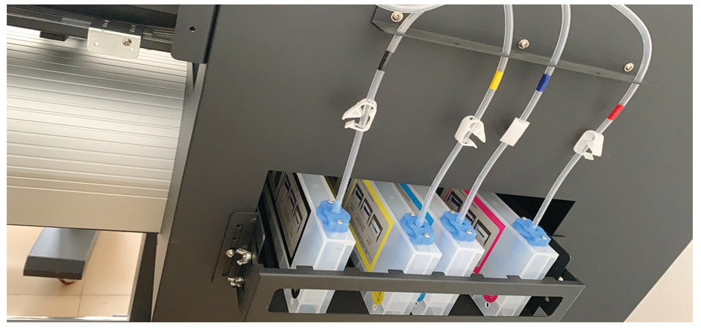

Print head Maintenance Station(Print Head cleaning station)

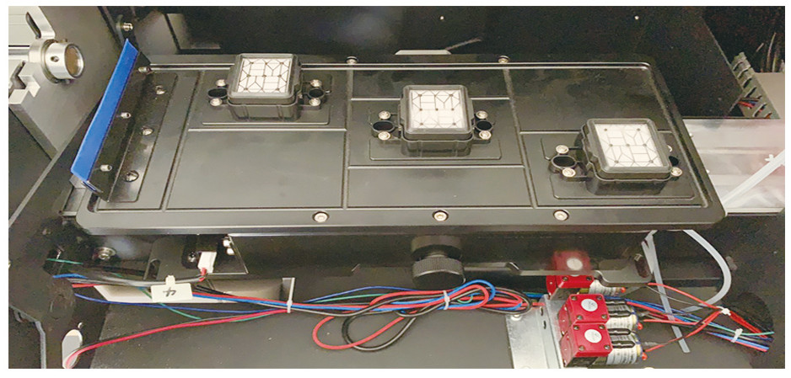

Media Pinch Roller

